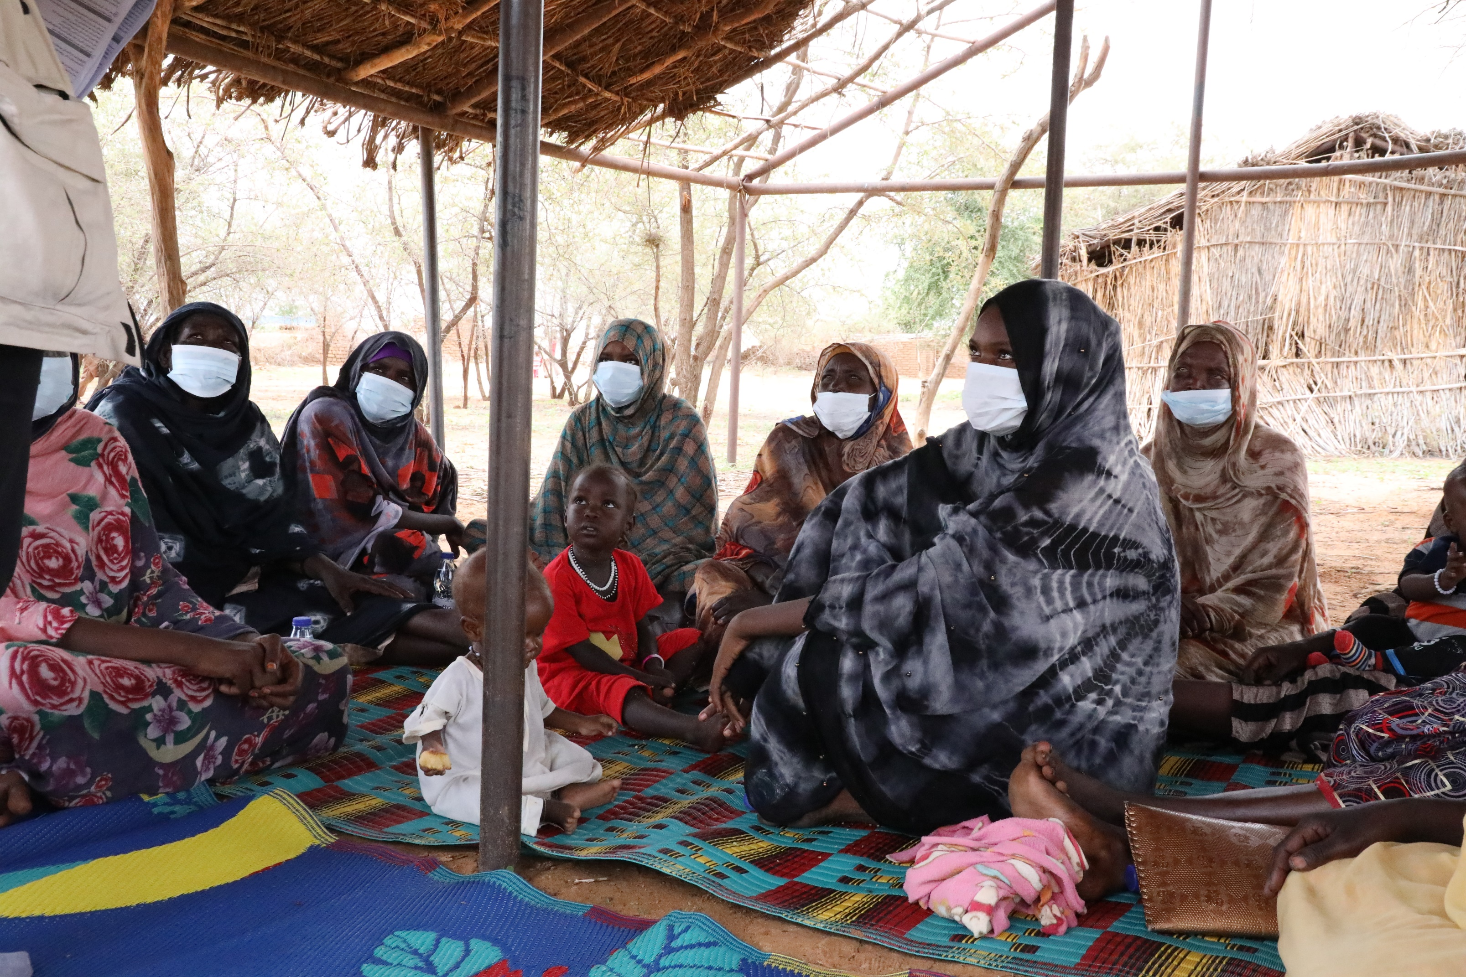
LEGAL IDENTITY & CIVIL DOCUMENTATION
The Norwegian Refugee Council (NRC) is an independent humanitarian organization helping people forced to flee. We work in crises across 31 countries, providing life-saving and long-term assistance to millions of people every year.
NRC works to protect the rights of displaced and vulnerable persons during crisis. In Sudan, NRC is implementing programmes under the Water sanitation and hygiene, Food security and Livelihoods, Education, Shelter and settlement, Camp coordination & camp management, Information counselling & Legal Assistance areas of competence.
Information, Counselling & Legal Assistance (ICLA) is a legal aid programme seeking to assist displaced persons to claim and fulfil their rights through application of information, counselling and legal assistance services.
In Sudan NRC ICLA conducts activities on Housing Land and Property (HLP) issues, Civil and Identity Documentation and Employment laws and procedures.
THE NORWEGIAN REFUGEE COUNCIL
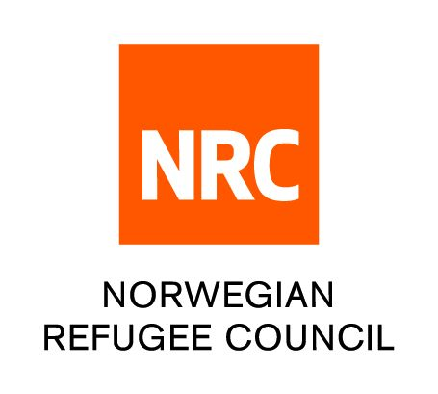
All information provided in this document is intended as a general guide only and is not a substitute for seeking advice from a qualified lawyer and/or government authorities. The information in this leaflet is subject to change and individuals should ensure that they obtain up to date information

INFORMATION SHEET ON

Legal identity
- Legal identity refers to the right to be recognized as individual before the law and entitles an individual to certain rights and protection under the law.
- According to International law, every person has the right to be recognized before the law.

Types of legal identity documents
In Sudan, the main identification documents for Sudanese are;
- National number – This is a unique number that is given to citizens at the time of their registration at the Civil Registry. It is a unique and unrepeatable number.
- Identity card – this is the main/ official identification document that is issued to every Sudanese who reaches the age of 16. Identity cards may be issued for those who are less than that age, if necessary.
- Citizenship certificate – The document is mainly carried by Sudanese citizens who are born abroad.
- Civil registry certificate - the certificate given to the individual after the completion of his registration in the Civil Registry.
- Any other document issued by the Civil Registry

In Sudan the main identification documents for refugees is:
Refugee Biometric Identity Card– the document is issued by the Commissioner of Refugees and UNHCR. It is the main identification documents for refugees in Sudan.
What is civil registration?
Civil registration is the continuous and permanent recording of the occurrence and characteristics of vital incidents.
In Sudan, vital incidents can be; Live birth • Adoption • Death • Adoption • Marriage • Divorce
Civil documentation is any official document issued by civil registrar or any other authorised state body upon registration of a vital incident. The

registration process enables government to obtain vital information about its citizens for purposes of planning for the delivery of services
Registration at the civil registry in Sudan.
- Each citizen should register themselves in the civil registry center in which area where they permanently reside.
- Every family must inform the civil registry of any vital incident including birth, marriage, divorce and death incident that may have occurred in the family.
- When there is change in permanent residence

Civil documents DO NOT include;
- Identity and travel documents;
- Documentation related to immigration status and legal residency;
- Documentation related to granting asylum, or registration as a refugee or
- Internally displaced person with authorities or international agencies;
- Education certificates and/or diplomas;
- Driving licenses;
- Work permits.

THE DIGITAL COMMUNITY HUB
- Call NRC for free on 015 655 9807
- Information available in English, Arabic, Tigrinya and Amharic (from 8:00 AM to 4:00 PM every day).
- If you are a Refugee or Internally Displaced Person in Khartoum, get information on obtaining legal documents and on our Cash for Food Programme.
- The call will not cost you anything.
- You can also leave us a message with your complaint or feedback on our services and we wll get back to you (Sunday - Thursday, between 8:00 AM and 4:00 PM)

www.nrc.no

